|  |
| --- |
| SAVCHENKO INC |
| Side Scroller Thing |
| **Game Concept and Proposal** |
| Version #0.1  All work Copyright © 2012 by SAVCHENKO INC.  All rights reserved. |
| **George Savchenko** |
|  |



|  |
| --- |
| May 16th 2012 |

**Table of Contents**

Table of Contents

Version History 3

I. Game Overview 4

I. Game Play Mechanics 4

*II.* Camera 4

III. Controls 4

IV. Interface Sketch 44

V. Menu and Screen Descriptions 44

VI. Game World 4

VII. Game World Game Progression 5

VIII. Characters 5

IX. Enemies 5

X. Abilities 5

XI. Scoring 5

XII. Story Index 5

XIII. Art / Multimedia Index 5

XIV. Design Notes 6

XV. Future Features 6

Version History

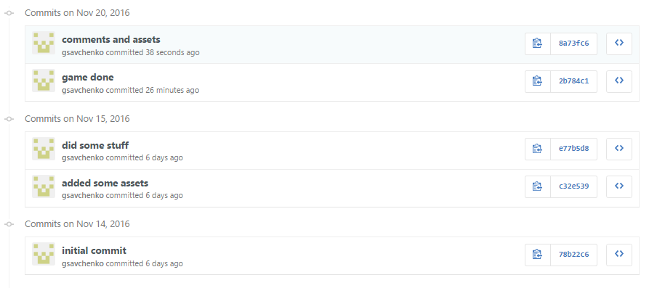

1. Game Overview

*You play as an bird trying to eat stuff as you fly to the right at a constant pace. Your score is measured by amount of stuff you eat before you reach the end (very right) of the level. The goal is to get the highscore.*

1. Game **Play** Mechanics

*Player is a dot/bird moving right constantly trying to collect other dots/food. Can only move up and down. Game is over once the end of the level is reached.*

1. Camera

*2D Game Environment*

1. Controls

*Standard keyboard control.*

1. Interface Sketch



1. Menu and Screen Descriptions



1. Game World

*The game world is a 2D environment.*

1. Game World Game Progression

*The screen moves the the left as the player moves forward (to the right).*

1. Characters

*Bird circle thing.*

1. Enemies

*Food circle things.*

1. Abilities

*Eat enemies.*

1. Scoring

*The more enemies you eat the higher the score becomes.*

1. Story Index

* *You are bird circle thing*
* *You want to eat food circle things*

1. Art / Multimedia Index

C:\Users\Heorgi\Desktop\on-going projects\Side-Scroller\Assets\images\spritesheet.png

1. Design Notes

*Simple and elegant*

1. Future Features

*Better art*